<<Haijima>>



High level specification

I was in charge of the firing logic, and testing the robot to ensure it performed well. This involved experimenting and analysing battle statistics across multiple rounds to identify weaknesses and improve consistency.

In Robocode, statistics such as Survival and Bullet Damage contribute heavily to the final score, so the definition of a successful robot would be one that can survive consistently while landing accurate shots.

Throughout the project, I developed practices such as performance analysis, and refining tank behaviour based on experimental results. I also learned the importance of adapting strategies for different battle sizes.

Strategy

My goal was to make Amaterasu hit most of her shots.
One of my teammates wrote this:

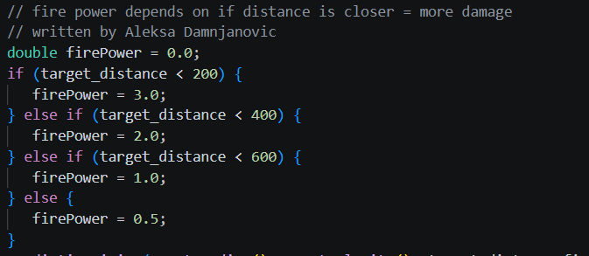

Which I used for my predictiveFiring() initialization and prediction calculations, ensuring we don’t waste energy.

Survival vs Scoring
You get rewarded the most points for surviving, so a bot which has a good energy management, constantly hits their shots and has decent uninterrupted movement will survive longer. Therefore, scoring higher. Our bot checks all of those boxes except for the fact that our current onHitRobot(), onBulletHit(), and onHitByBullet() may cause us to score lower in bigger battles.

Progress

First iteration
I figured out the initial logic for predictiveFiring() but it wasn’t working.

Second iteration
My main goal was to fix predictiveFiring() as it was doing incorrect calculations resulting in our gun not turning and firing. My secondary goal was to test our tank and ended up finding Bug 002.

Third Iteration
My main goal was to fix Bug 002 and test our robot extensively to ensure it was performing. I also wanted to play around with onHitRobot(), onBulletHit(), and onHitByBullet() methods since they were causing our tank to perform worse(but didn’t end up doing so).

Over each iteration our firing logic became better and better.

Robot performance
The results of me testing our robot in battles are in Review 3 but I’ll paste them here:

While onHitRobot(), onBulletHit(), and onHitByBullet() are enabled results:

- Amaterasu vs Crazy 100 round results
- Amaterasu vs 10 other bots 100 round results
- Amaterasu vs 23 other bots 100 round results

While onHitRobot(), onBulletHit(), and onHitByBullet() are disabled results:

- Amaterasu vs Crazy 100 round results
- Amaterasu vs 10 other bots 100 round results
- Amaterasu vs 23 other bots 100 round results

Team performance
The team did well, though two of them didn’t show up for the Review 2 presentation.

I don’t think I did enough contribution to our code despite the firing logic being a core component of a tank.

I really wish I had paid attention to the fact that basic robots can only do one action per tick, I would’ve been able to fix Bug002 sooner.

Git Practices

While working on the code, I found myself committing over every little thing. I would spam the git branch, and git config user.email to ensure I was working on the correct branch and was using the correct email.

When I would work on features, I’d always make a separate branch, since the main branch is sacred. I always tried to summarize what I’ve done in my commit messages. I personally encountered a problem where I committed from my personal git account and I had to override them to display my student email as the author, but besides this git was pretty straight forward.

Implementation

The robot was implemented using the Robocode Robot API and relies on event-driven behavior through callback methods such as onScannedRobot(), onHitWall(), onHitRobot(), onHitBullet() and onHitByBullet(). The robot combines predictive targeting, orbit-based movement, wall avoidance, and adaptive firing strategies to improve survival and combat effectiveness.

Methods I worked on breakdown:
The run() method controls the robot’s main behavior loop. It continuously scans for enemies, updates movement, and adjusts radar positioning.

predictiveFiring() estimates the future position of an enemy by repeatedly calculating their future position based on its heading, velocity, distance from us and position until the estimated bullet travel distance matches the enemy distance. The gun is then rotated toward the predicted position before firing.

onScannedRobot() is responsible for tracking enemies. When an enemy is detected, we choose what firepower to use and call predictiveFiring().

randomColor() generates a new Color object based on random RGB values.

Bug Report

Bug 001

behaviourByEnergy() used to cause problems with the orbitEnemy() and goToCentre() methods, where our tank was constantly changing direction and not doing enough shooting. To replicate revert the code back to how it was before this commit: 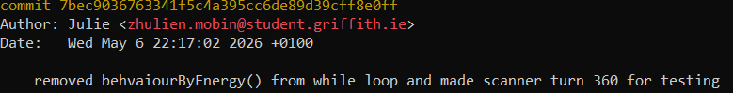

Bug 002

predictiveFiring() would occasionally fire out of bounds, but my teammate added a clamp to ensure it doesn’t:

